BEST BUYS
Pearson Edexcel - Tuesday 6 November 2018 - Paper 1 (Non-Calculator) Foundation Tier

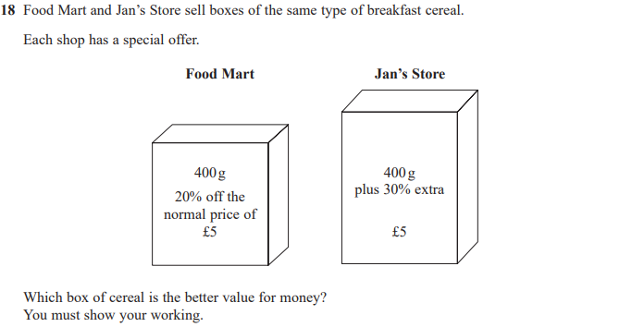

Pearson Edexcel - Wednesday 8 November 2017 - Paper 3 (Calculator) Foundation Tier

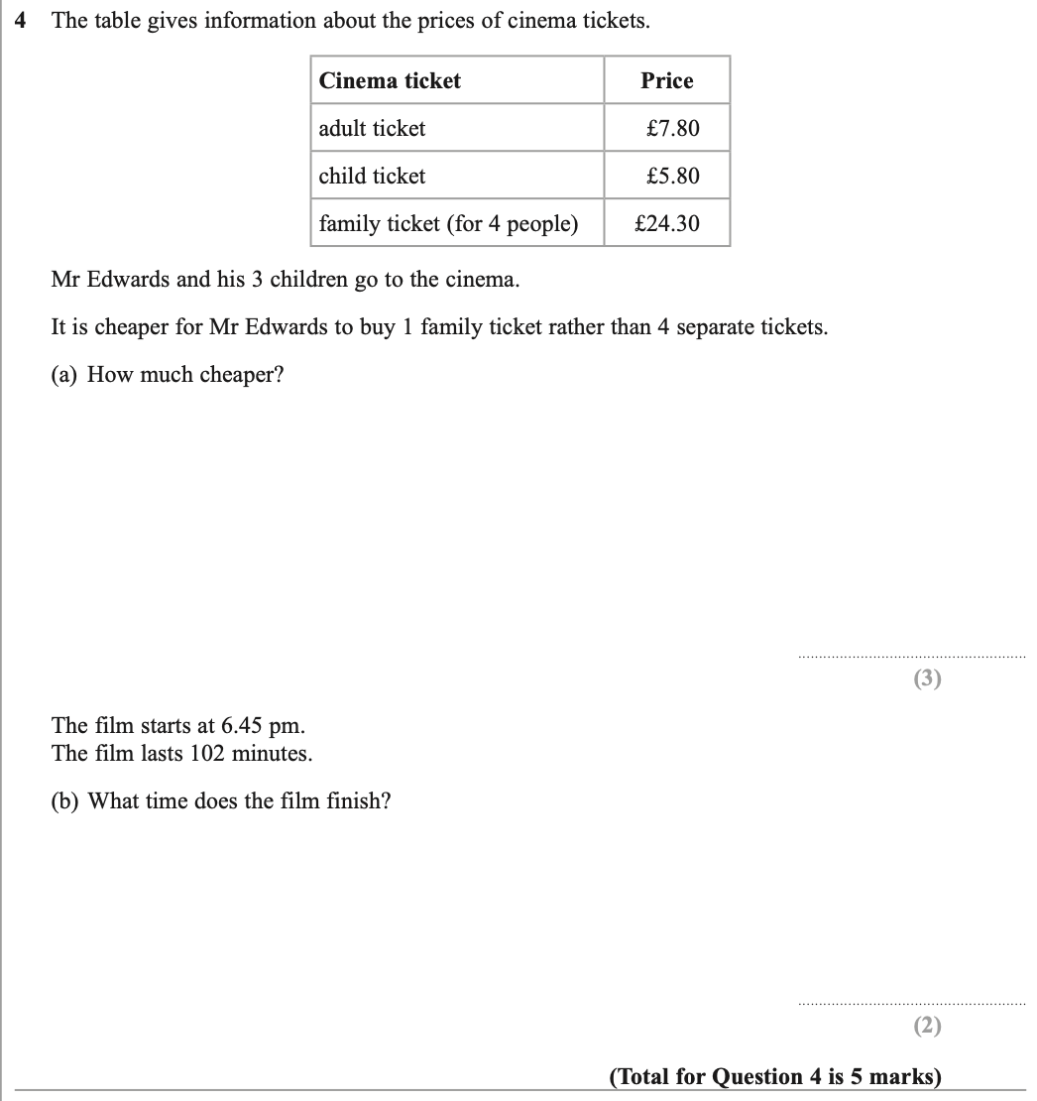

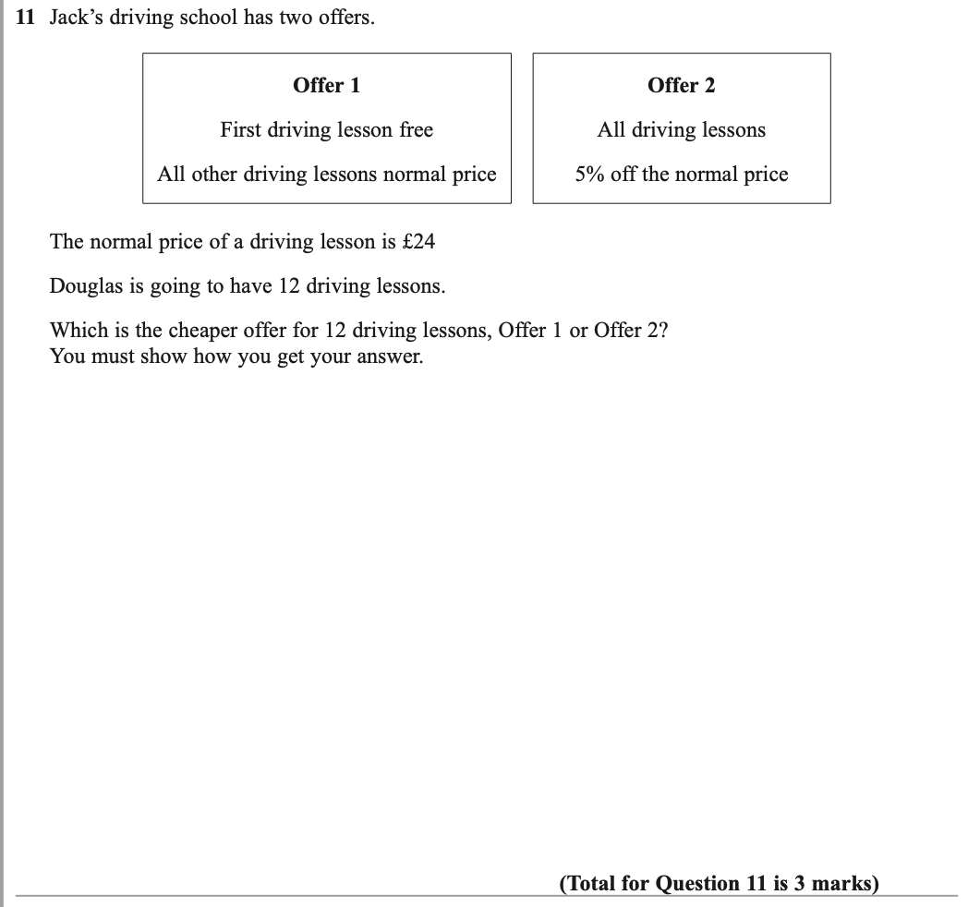

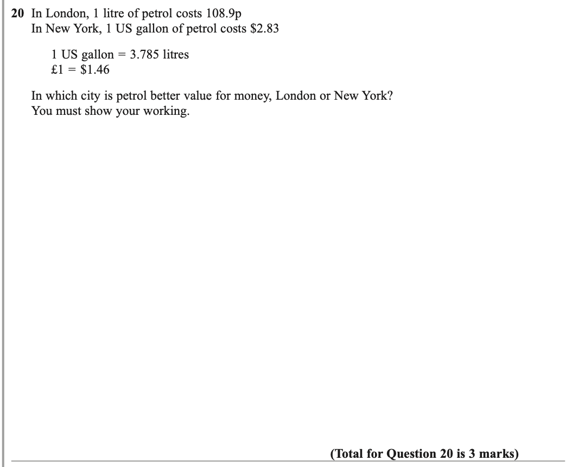

OCR Tuesday 6 November 2018 – Morning (Calculator) Foundation Tier
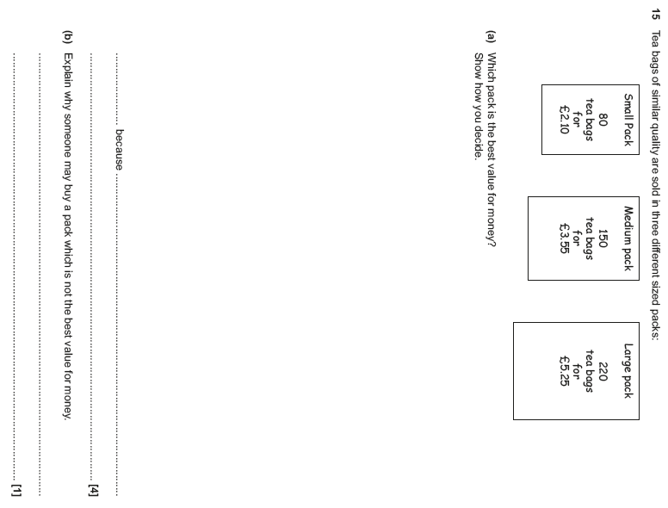

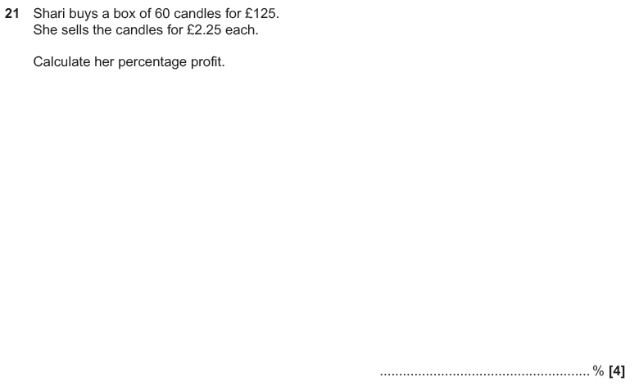

OCR Tuesday 12 June 2018– Morning (Calculator) Foundation Tier
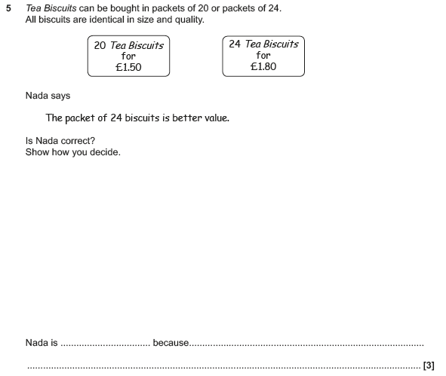

OCR Monday 6 November 2017– Morning (Calculator) Foundation Tier
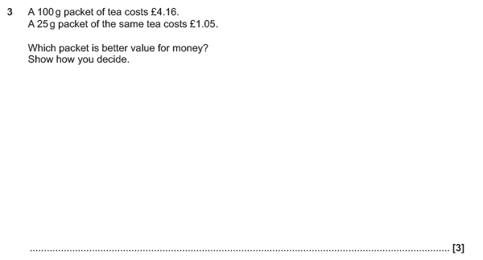

Pearson Edexcel – Sample Papers - Paper 1 (Non-Calculator) Foundation Tier

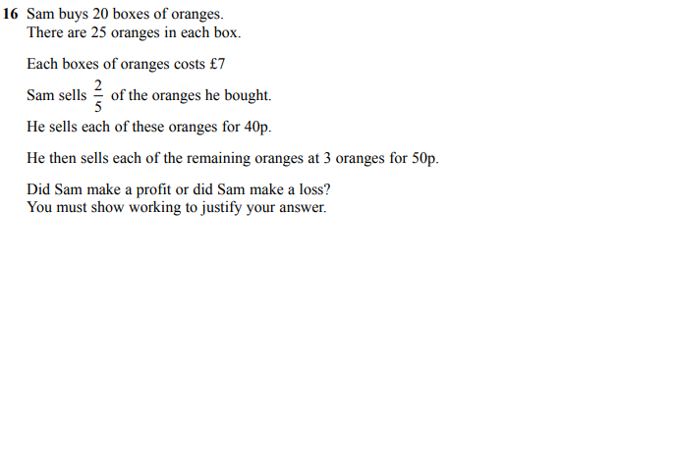

Pearson Edexcel –Sample Papers - Paper 2 (Calculator) Foundation Tier

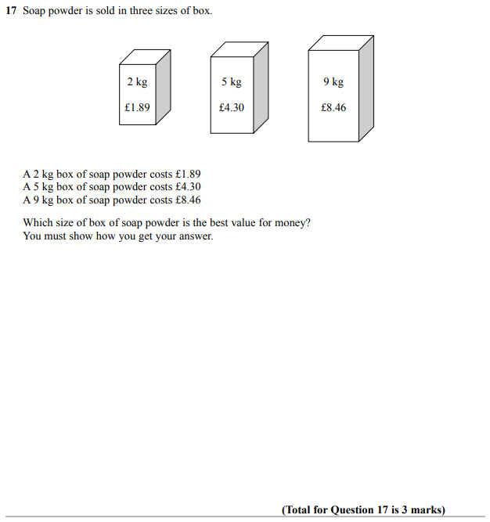

Pearson Edexcel – Sample Papers - Paper 3 (Calculator) Foundation Tier

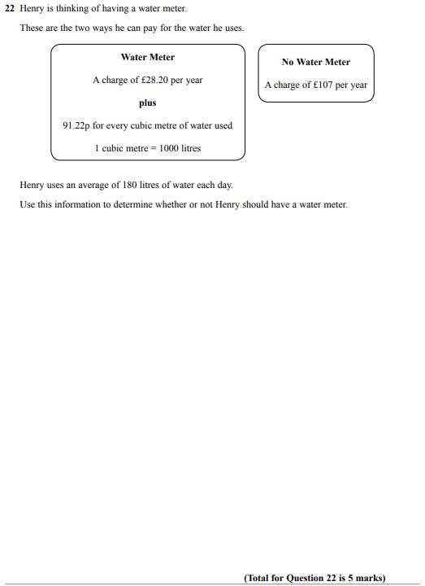

OCR Sample Question Paper 1 – Morning/Afternoon (Calculator) Foundation Tier

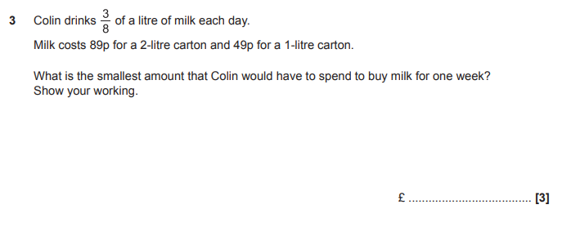

AQA Monday 8 June 2020 – Morning (Calculator) Foundation Tier

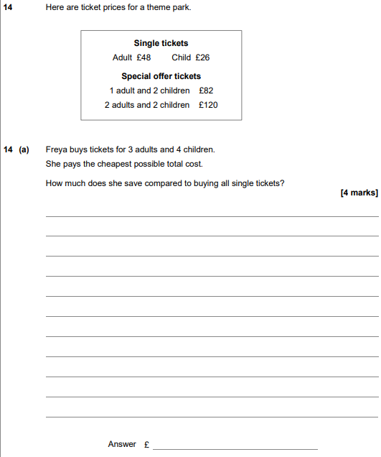

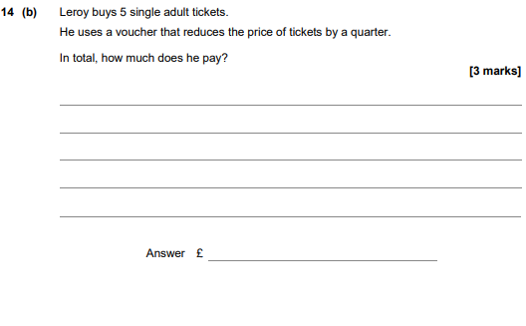
AQA Thursday 11 June 2019 – Morning (Calculator) Foundation Tier

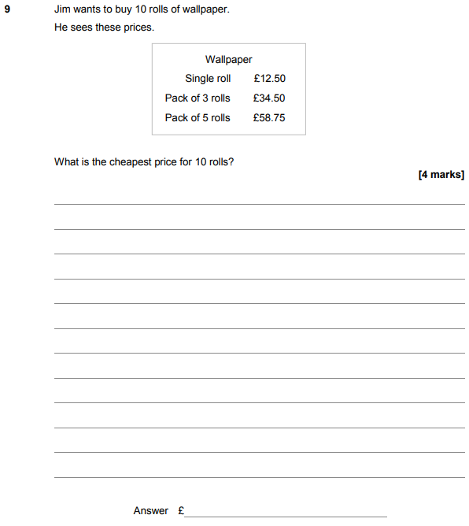

AQA Tuesday 13 June 2017 Morning– Morning (Calculator) Foundation Tier

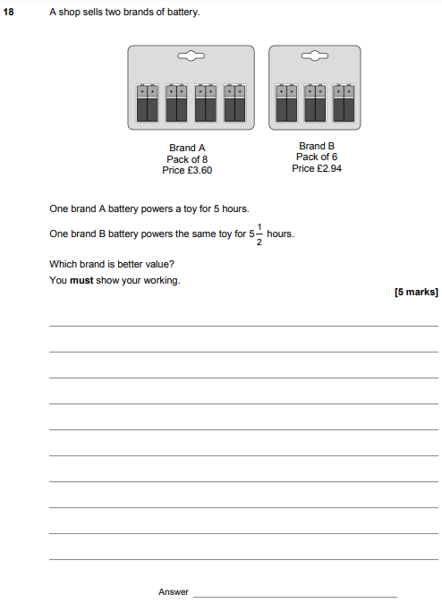

AQA Sample Paper 2– Morning (Calculator) Foundation Tier

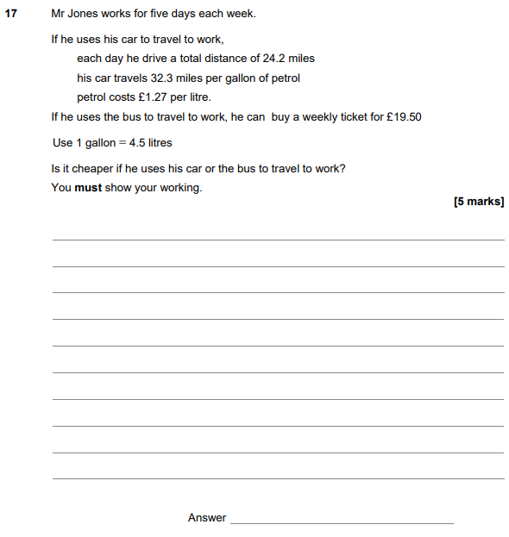

AQA Sample Paper 3– Morning (Calculator) Foundation Tier

